Morphological Operations Using Black Hat
Experiment No: 35
Aim
To perform the morphological Black Hat operation on an image using OpenCV in Python
Tools Required
- Python 3.x
- OpenCV (cv2)
- NumPy
- VS Code / PyCharm / Jupyter Notebook
- Input image (image.jpg)
Theory
The Black Hat morphological operation is used to extract small dark objects or details from an image.
It is calculated by subtracting the original image from its Closing operation:
OpenCV provides the cv2.MORPH_BLACKHAT operation to perform this directly.
Procedure
- Install OpenCV and NumPy:
Bash
pip install opencv-python numpy
- Read the input image using OpenCV.
- Convert the image to grayscale.
- Create a structuring element (kernel).
- Apply the Black Hat operation using cv2.morphologyEx().
- Display the original and Black Hat images.
- Save the resulting image.
Code
import cv2
import numpy as np

# Read the image
image = cv2.imread("image.jpg")

# Check if image is loaded
if image is None:
print("Error: Image not found!")
exit()

# Convert image to grayscale
gray = cv2.cvtColor(image, cv2.COLOR_BGR2GRAY)

# Create a structuring element
kernel = np.ones((5, 5), np.uint8)

# Perform Black Hat operation
black_hat = cv2.morphologyEx(
gray,
cv2.MORPH_BLACKHAT,
kernel
)

# Display original image
cv2.imshow("Original Image", gray)

# Display Black Hat image
cv2.imshow("Black Hat Image", black_hat)

# Save the output
cv2.imwrite("black_hat_image.jpg", black_hat)

cv2.waitKey(0)
cv2.destroyAllWindows()
Output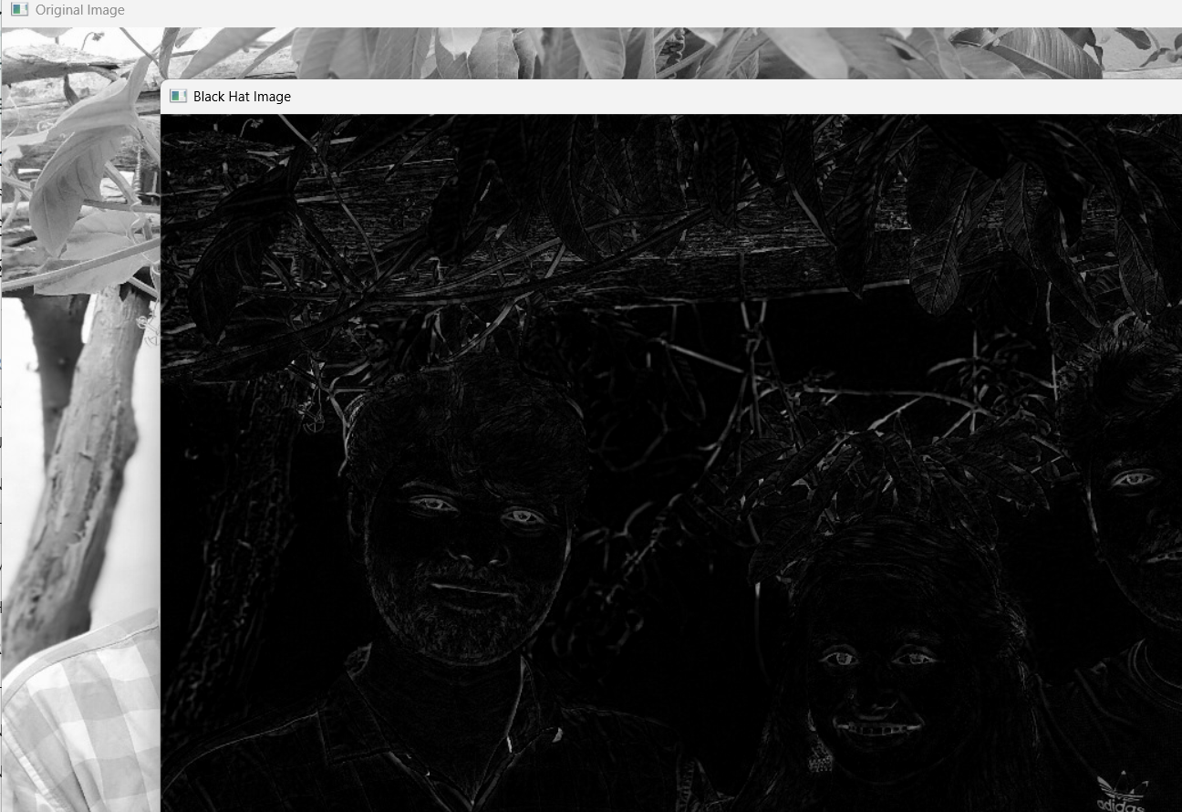
Result
The morphological Black Hat operation was successfully performed using OpenCV. The operation extracted small dark regions and fine details from the image by subtracting the original image from its morphological closing.

